**APPLICATION DEPLOYMENT**

1.jenkins login page, configuration setting,execute step command

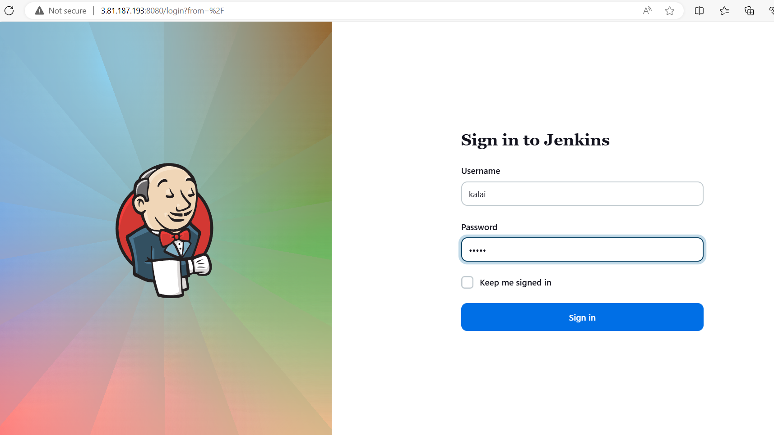

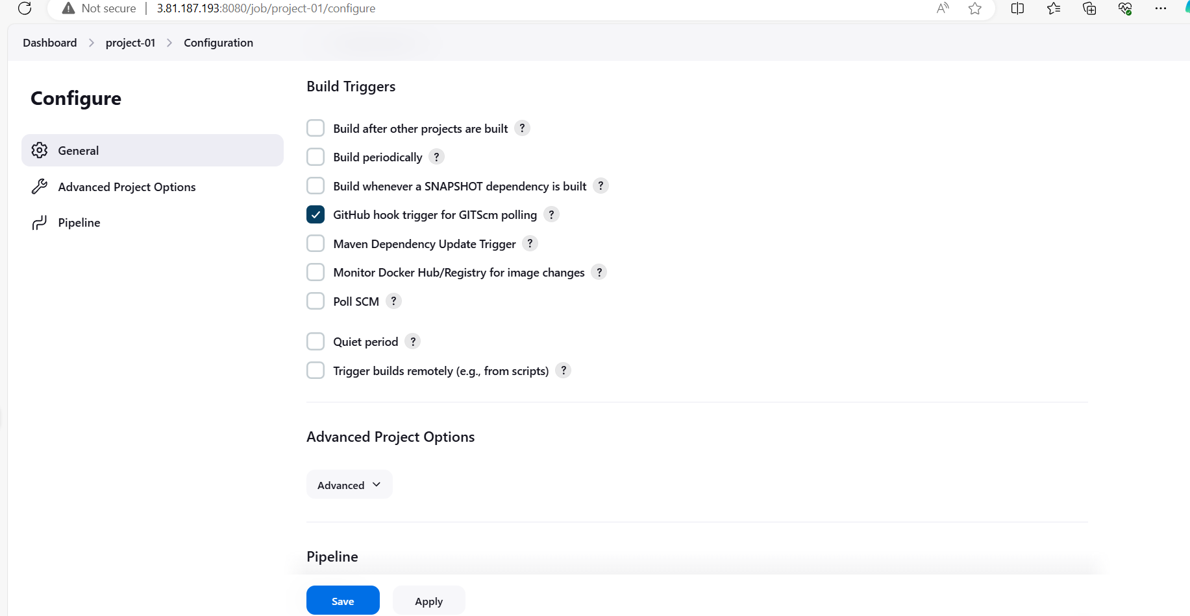

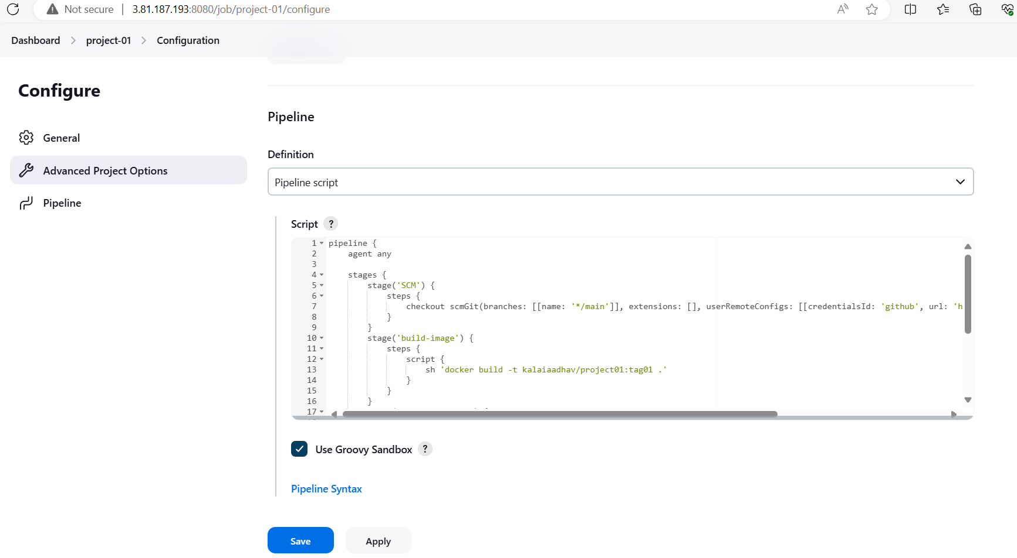

**2.EXECUTED COMMANDS**

pipeline {

agent any

stages {

stage('SCM') {

steps {

checkout scmGit(branches: [[name: '*/main']], extensions: [], userRemoteConfigs: [[credentialsId: 'github', url: 'https://github.com/kalaiaadhav/devops-build.git']])

}

}

stage('build-image') {

steps {

script {

sh 'docker build -t kalaiaadhav/project01:tag01 .'

}

}

}

stage('push-dockerhub') {

steps {

script {

withDockerRegistry(credentialsId: 'dockerhub') {

sh 'docker push kalaiaadhav/project01:tag01'

}

}

}

}

}

}

**OUTPUT**

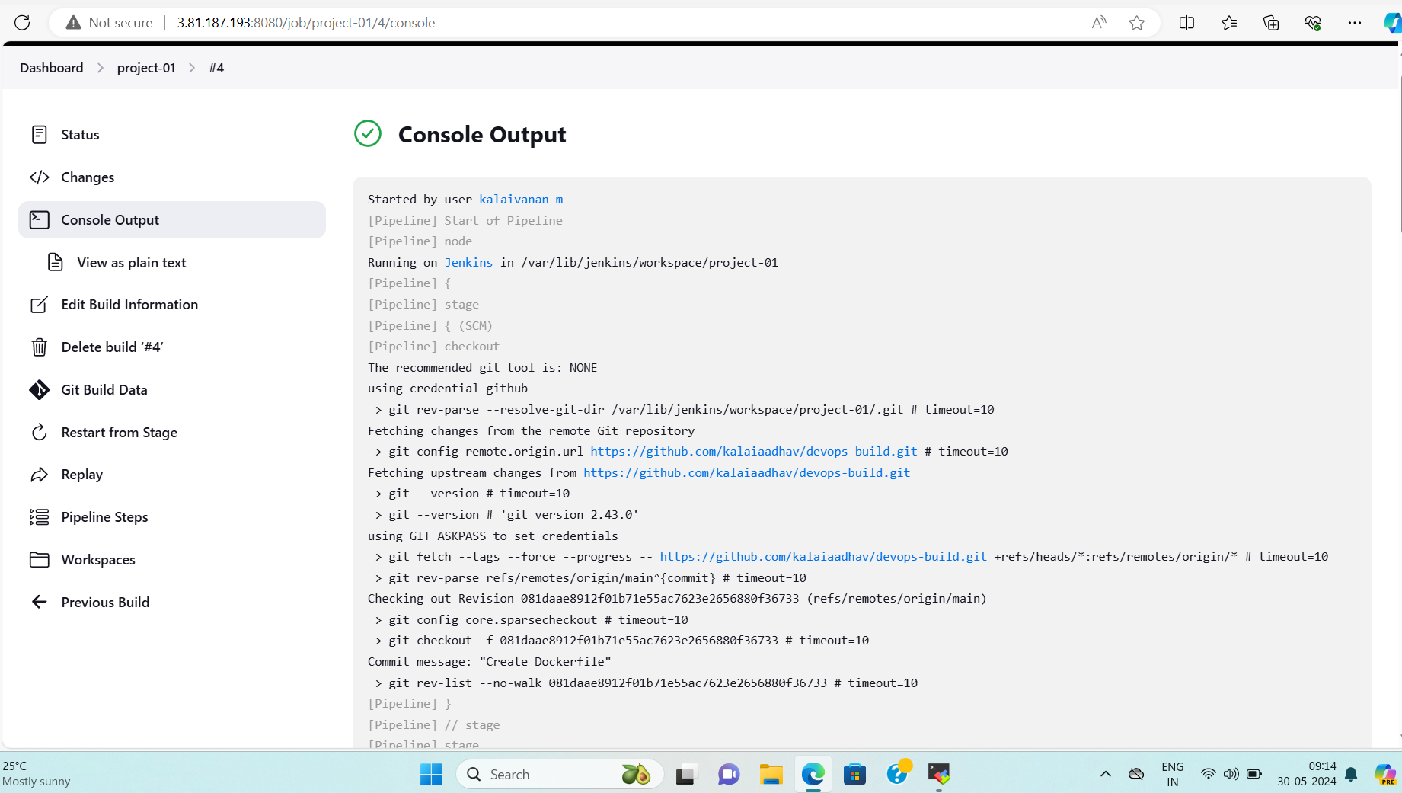

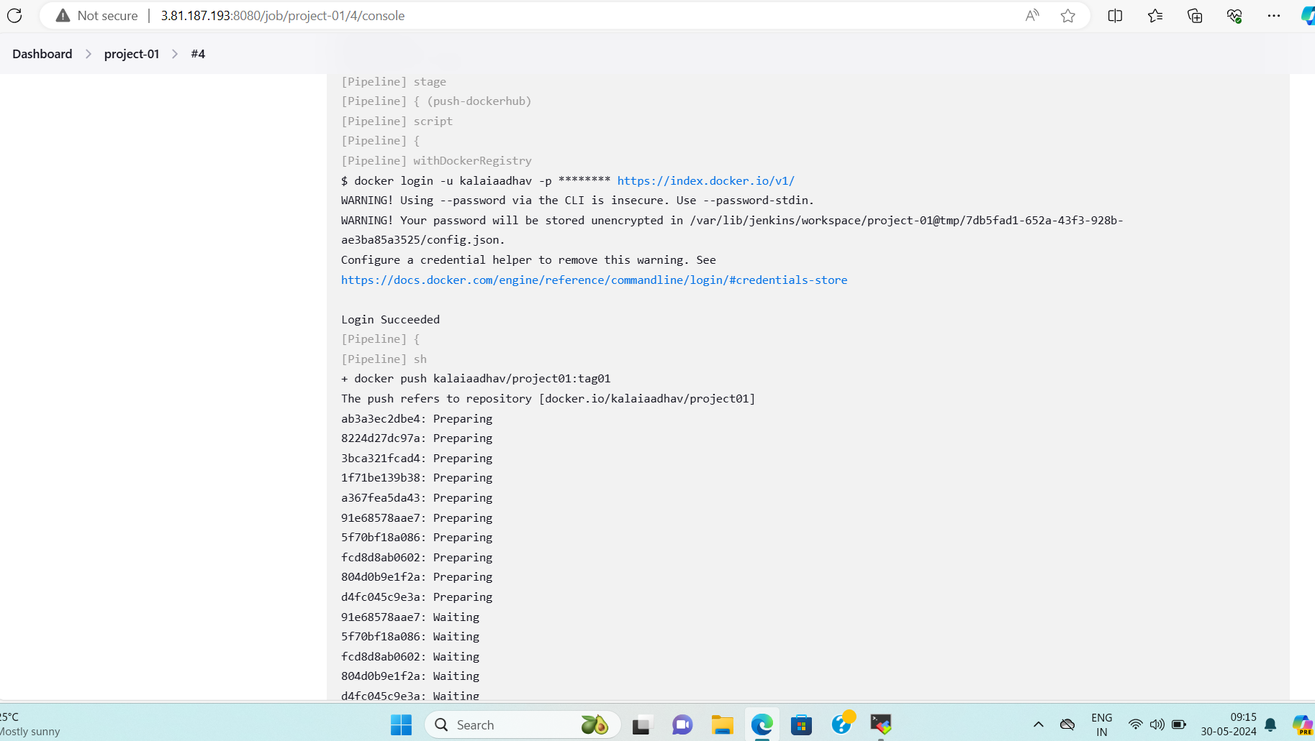

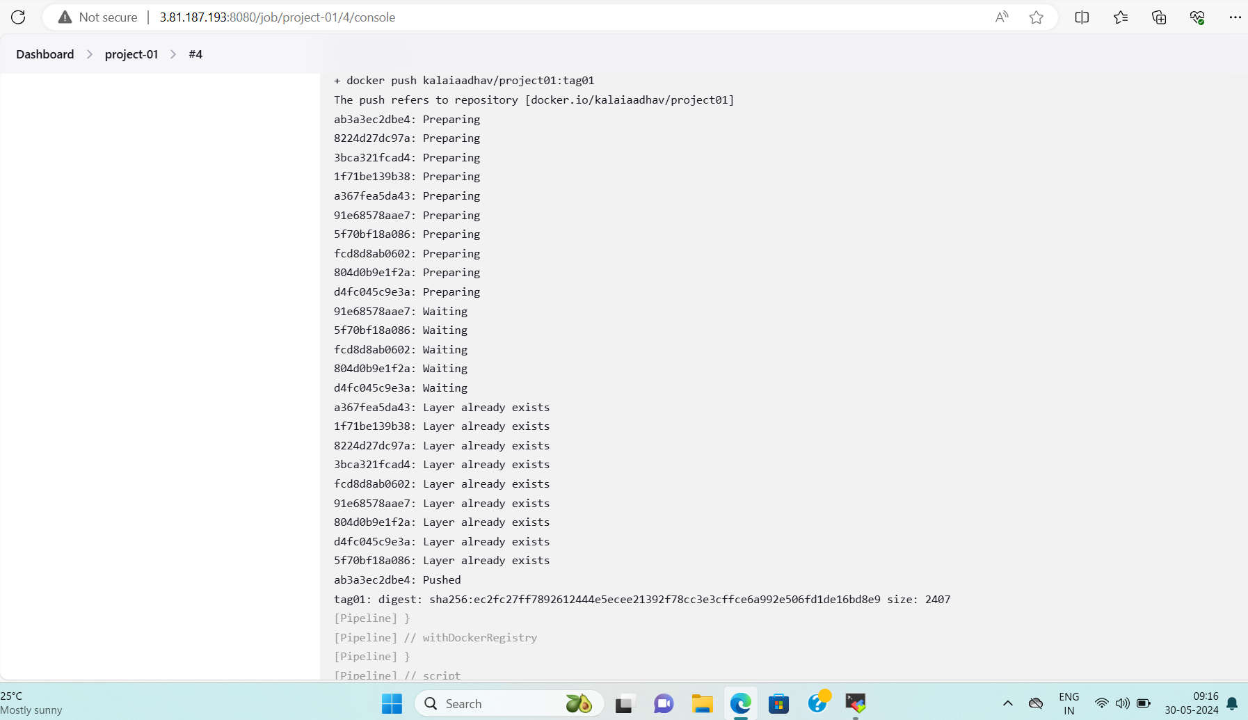

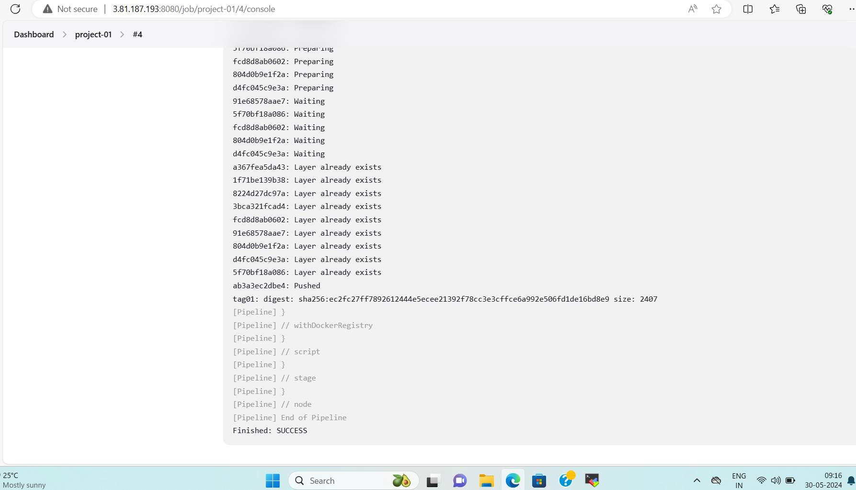

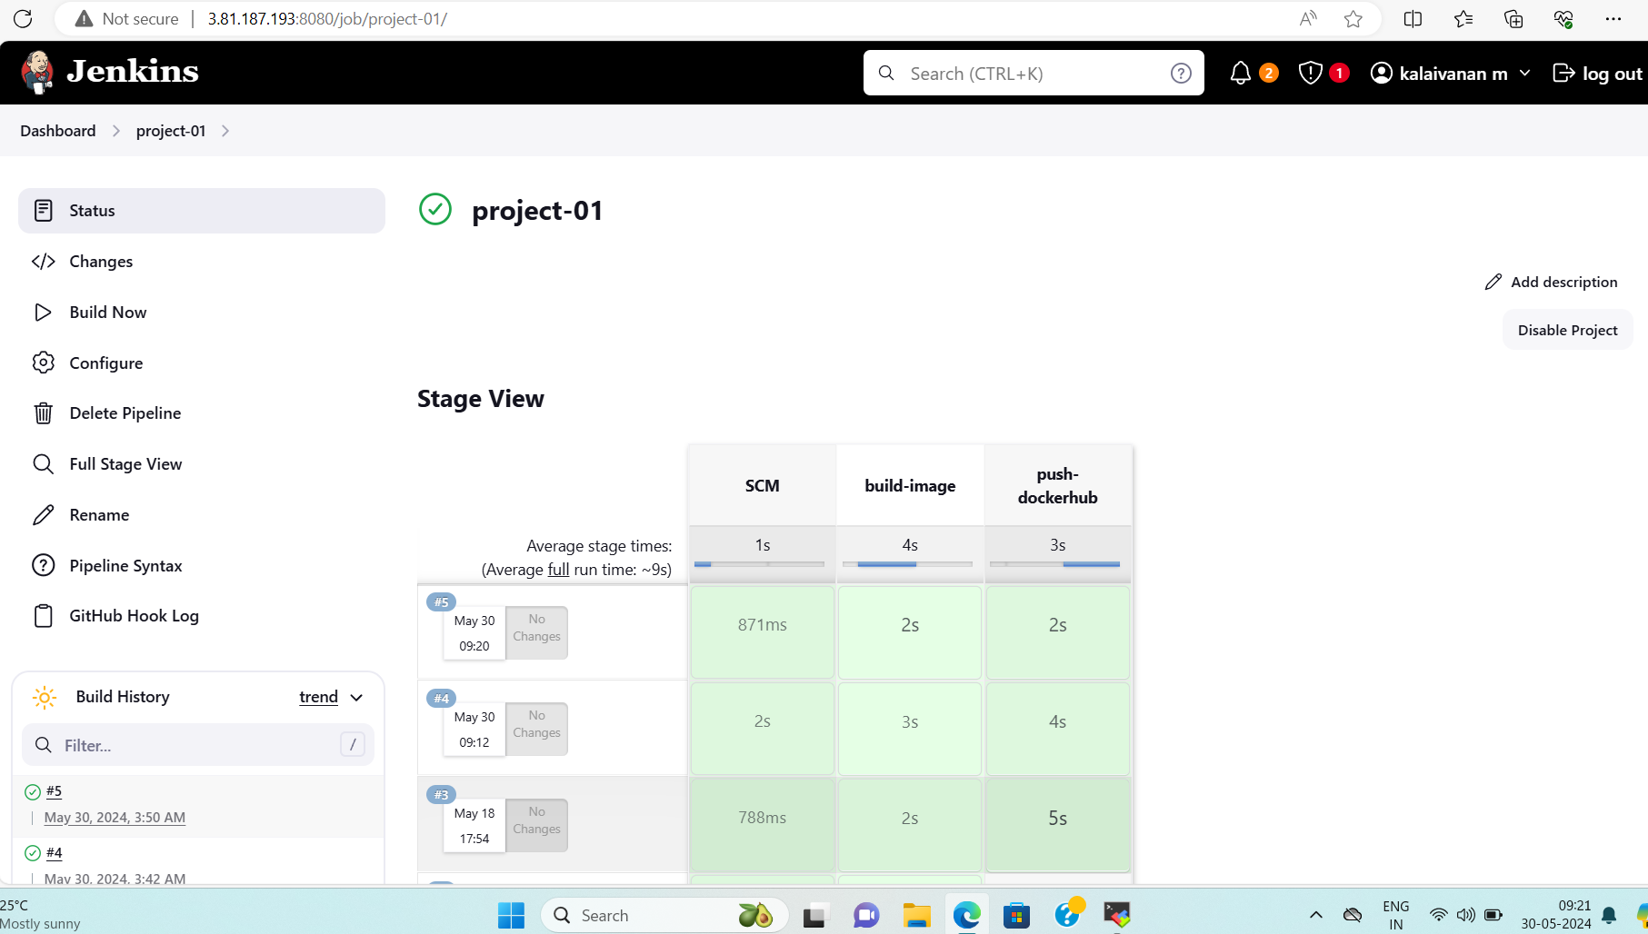

**DOCKER HUB PUSHED**

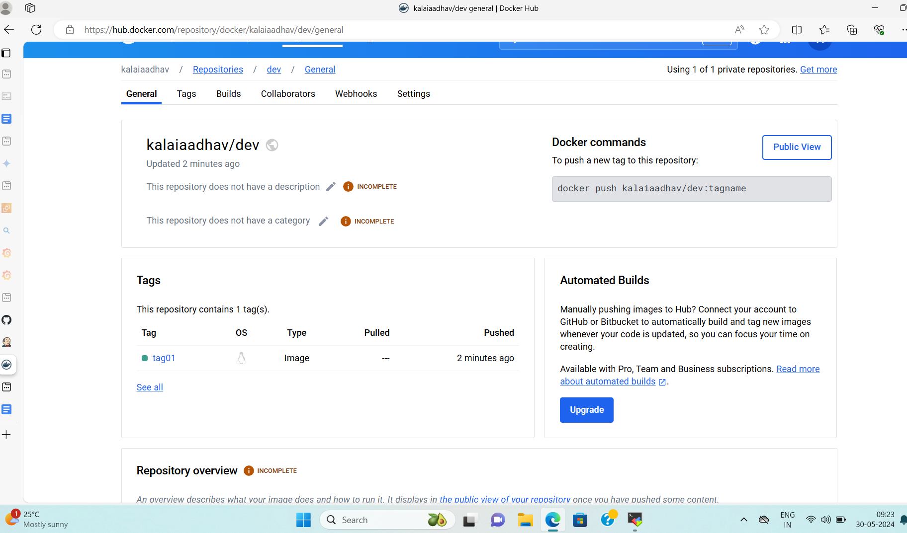

**AWS EC2 CONSOLE**

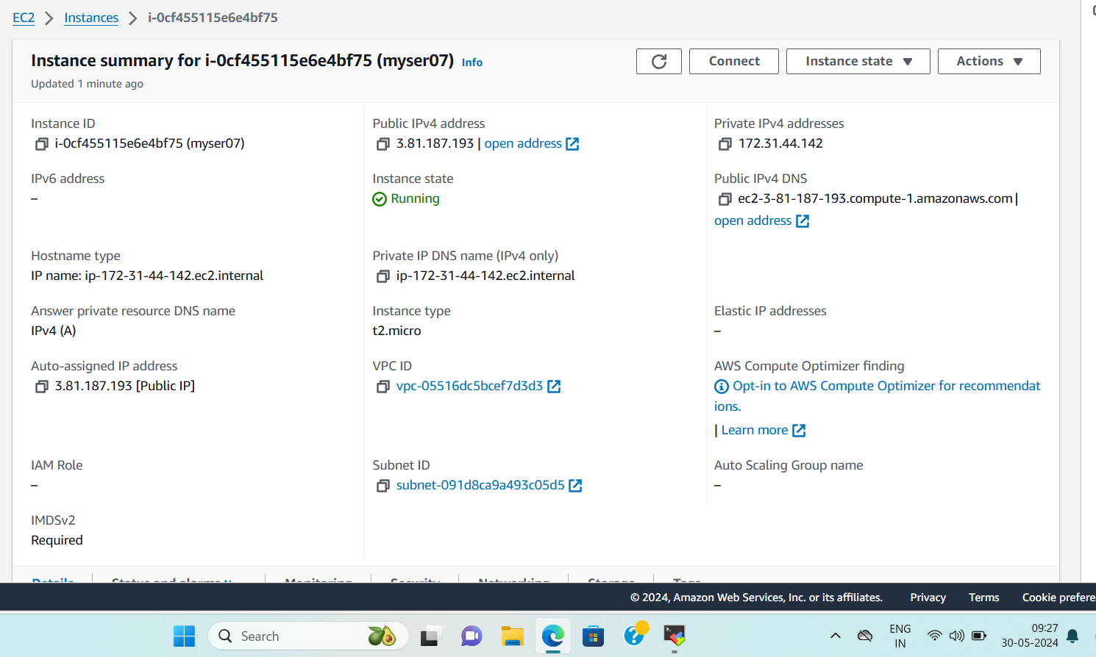

**SG**

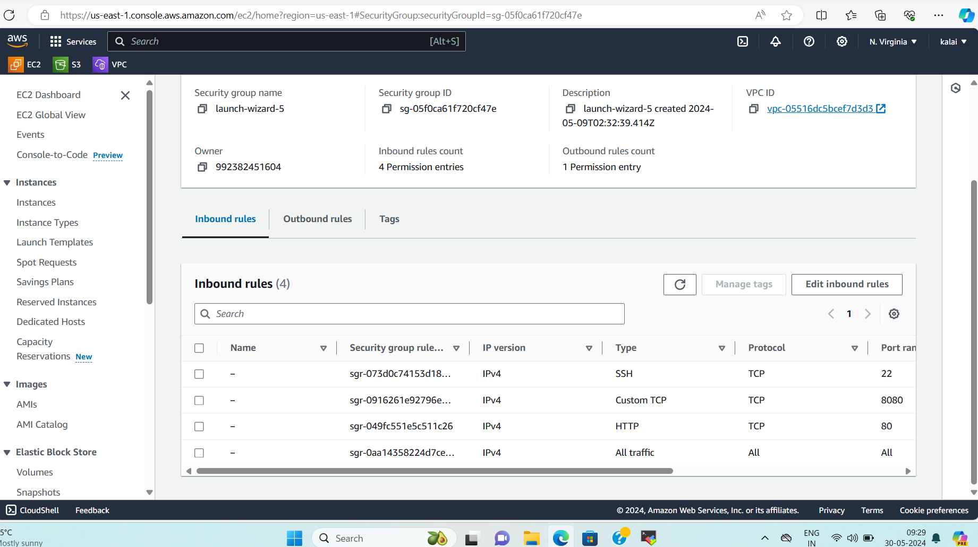

**DEPLOYED SITE PAGE**

**URL** [**184.73.121.213**](http://184.73.121.213/)

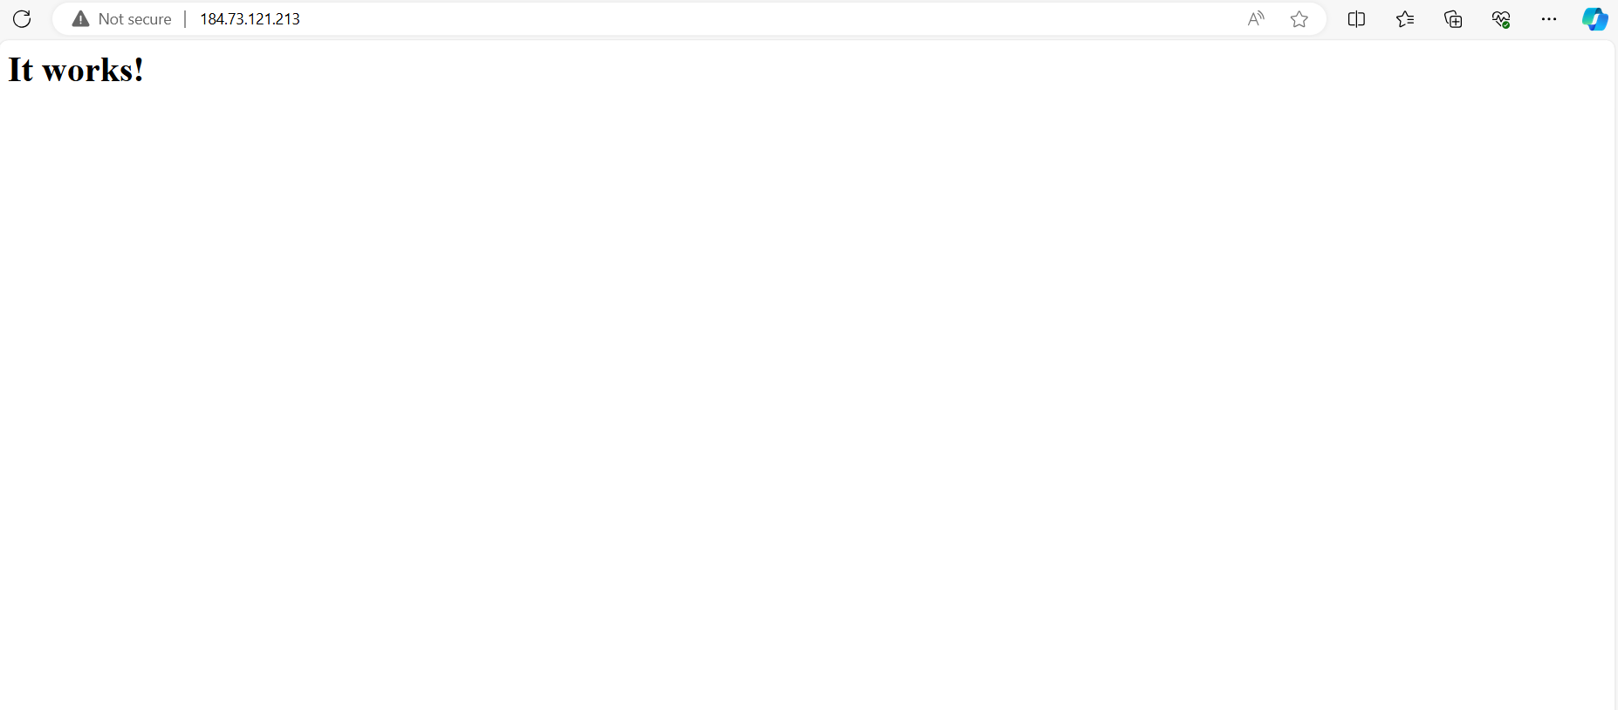

**PROMETHUS MONITORING**

